Computer Language Coding Concepts

Command Calls in a Command Call in a Diagram
This article demonstrates a situation of command objects.

This article illustrates how command calls in a command call look in a diagram.

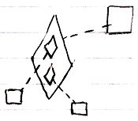

The bigger diamond is a command call, because it is tied to its definition, the larger square, with a dashed line, a class line. The smaller diamonds inside the larger diamonds are command calls inside a command call. The smaller diamonds also point out their definitions, the smaller squares, with a dashed line, a class line.

See also: Commands

Author & Copyright: Jan-Joost van Zon Date: August 9, 2008 – August 23, 2008 Location: Oosterhout, The Netherlands Status: Finished

